**3 Setting up and interpreting difference equations (Measles)**

Set up the SEIR model of the transmission dynamics of measles in a closed population using difference equations:



St+1 =St –β∗St ∗It

Et+1 =Et +β∗St ∗It −f ∗Et

It+1 =It +f ∗Et −r∗It

Rt+1 = Rt + r ∗ It

We assume that individuals mix randomly and parameter values are given as follows:

Population 100000 people

Pre-infectious period 8 days

Infectious period 7 days

Basic reproduction number 13

Life Expectancy 70 years

Initial values (S,E,I,R)=(99999,0,1,0)

**PART I: Setting up difference equations**

1. Plot a graph for number of susceptible, pre-Infectious, infectious, and recovered populations during 200 days.

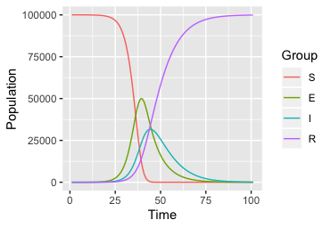

1. How long does it take before there are no infectious persons in the population? Why do no further new infectious persons occur in this population after a certain time?

According to the table, the number of infectious persons is less than one after 135 days. From the graph, it looks as though the number of infectious persons is zero after about 80 days. No further infectious persons occur in the population after a certain time as there are no more susceptible individuals - all have been infected, have become infectious and are immune to further infection.

1. How does the graph change if you change the pre-infectious period to be 5 days and 20 days, respectively?

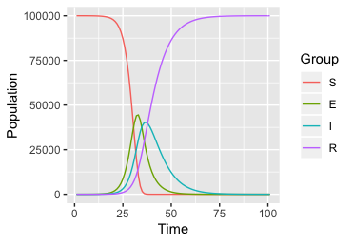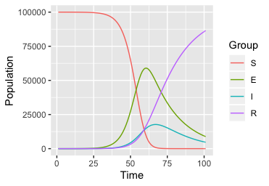

5 days 20 days

A long pre-infectious period results in a late increase in the number of infectious individuals. As a result, the opportunity for susceptible individuals to become infected is relatively small following the introduction of an infectious person into the population. This means that the decrease in the number of susceptible individuals occurs later. Also, the number of infectious individuals also takes longer to drop to zero if the pre-infectious period is assumed to be long than it does if the pre-infectious period is assumed to be short.

1. Which assumptions would you alter or add to the model to describe the transmission of measles in a large population over a period of years?

* increase the population size
* incorporate diversity in transmission between individuals (e.g. age-dependent transmission)
* incorporate individuals being born and dying in the population.
* incorporate imported infections (e.g. migrants) entering the population from other places

**PART Ⅱ: Incorporating births and deaths**

Modify the model to include the births and deaths in each time step and change the parameter values back to original:

1. Assuming that the population size doesn’t change over time, what would be an appropriate expression for the per capita birth rate and death rate?

birth rate = death rate = 1/life expectancy

1. Is it realistic that all individuals are born into the susceptible population? Is this a reasonable assumption to make? What alternative assumptions might be appropriate to make the model more realistic?

It is not realistic, since infants have some immunity derived from maternal antibodies. However, it is a reasonable assumption to make, since infants with maternal immunity comprise a relatively small proportion of the total population, and so will not contribute much to the overall transmission dynamics considered in this model. To make the model more realistic, you could add another “compartment” reflecting infants with maternally-derived immunity and have these individuals become susceptible to infection at a constant rate. The diagram would become as follows:



1. How does this change your answer to question Q2?

The answer should be very similar to that for Q2 (i.e. 80 days if you read this off a graph, 138 days if you look at the table).

*If you model the infection process over a long time period, then, given your background knowledge of measles, you would expect the number of infectious persons to oscillate over time.

1. How are the changes in the number of susceptible and immune related if you were to simulate the dynamics of measles for 50 years and for 100 years?



You should now see peaks and troughs in the number of susceptible and immune individuals occurring roughly every 3 years about 30 years after the start of the simulations. Note also that when the number of susceptible peaks, you see a dip in the number of immune individuals.

1. What happens if you change the time step to 2, 3, 4, and 5 days? Would it be reasonable to take a time step of 10 days?

Time steps of 2, 3 and 4 days shouldn’t influence the cycles - you should see that the cycles continue and the peaks become progressively smaller and eventually disappear.

With 5-day time steps, you should find that the cycles disappear completely and the number of susceptible/immunes drops to zero on the graph. This is due to the predicted number of new infections in each time step being larger than the number of susceptible present at the start of the time step, eventually leads to negative values for St.

Taking time steps of 10 days would not be sensible, since this time step is longer than either the pre-infectious or infectious periods and would mean that your predictions for the number of individuals in all categories in the model would not be very reliable.

